**MCS 2514 Computer Science 2**

Homework Two – Summer 2022

Prof. Khalil Khalaf

**You are provided a text file called “students.txt”:**

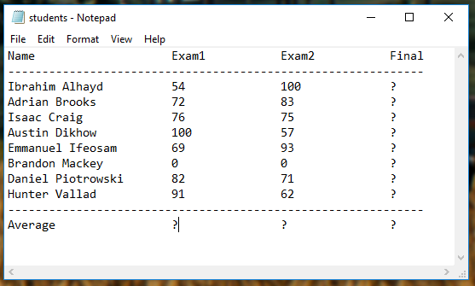

**Write a program that does the following:**

* + - * Reads all students names and their grades into a vector
      * Iterates and computes the final grade for each student
      * Iterates and computes the average grade for each exam
      * Iterates and computes the average grade from all final grades
      * Displays the name of the student who scored the maximum grade in each of the Exams
      * Displays the name of the student who scored the closest grade to the final average
      * Asks the user if they would like to save all results back to the file, and does so if user enters ‘Y’, else the program exists.

**Restrictions:**

* + - * The file you upload should include your name

**See results example on next pages.**

**Example one:**

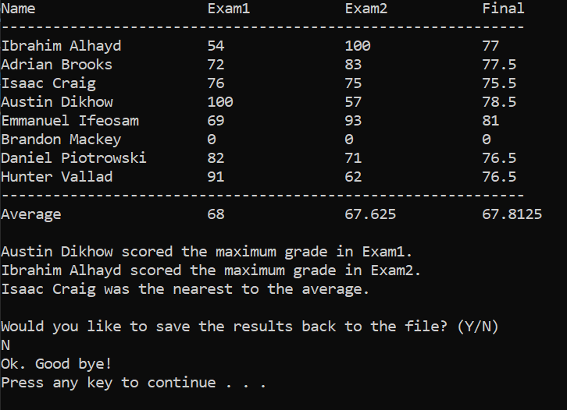

**Example Two:**

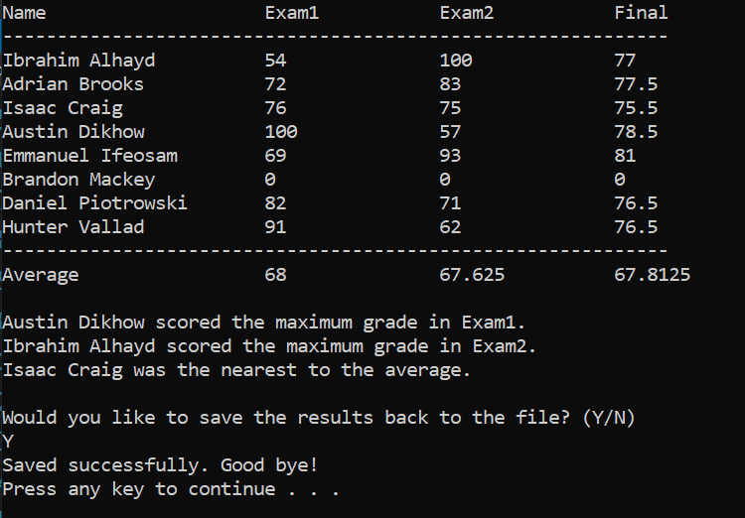

**Output file if user decides to save the results:**

